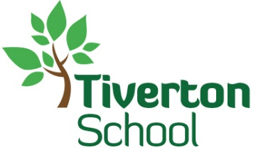

LEARN, ENJOY AND ACHIEVE

Parent/Carer Feedback
Children and families are at the heart of all we do. We value your feedback. We are asking your opinions on the following areas

Childs Name…………………………………………………………………………………. Class:………………………………………………………

Question | YES | NO | DON’T KNOW | COMMENTS
- My child is happy in school

2. My child feels safe at school

3. My child makes good progress at this school

4. My child receives homework as appropriate

Question | YES | NO | DON’T KNOW | COMMENTS
5. My child receives a book for us to share weekly

6. This school deals effectively with bullying
7. This school is well led and managed

8. This school responds to any concerns I raise

9. I receive valuable information about my child’s progress
10. I would recommend this school to another parent.
 | How might we know
11. Did you feel your child was supported through COVID 19 Lockdown? | - Keep in touch calls  - Homework Packs delivered and online  - Free School Meal Vouchers  - Food bank Vouchers  - Referrals to Social Care for support with your child
This form will be entered into a raffle. You could win a prize!!
Please take the time to complete the form and send it back to us no later than November 9th^{th} Thank You

Print name ……………………………………………………………………………………………………………….

Thank You

